TRABALHO DE SISTEMAS EMBARCADOS

Feito por Samuel Kimura e Richard Murilo

PRINT DO SEMÁFORO

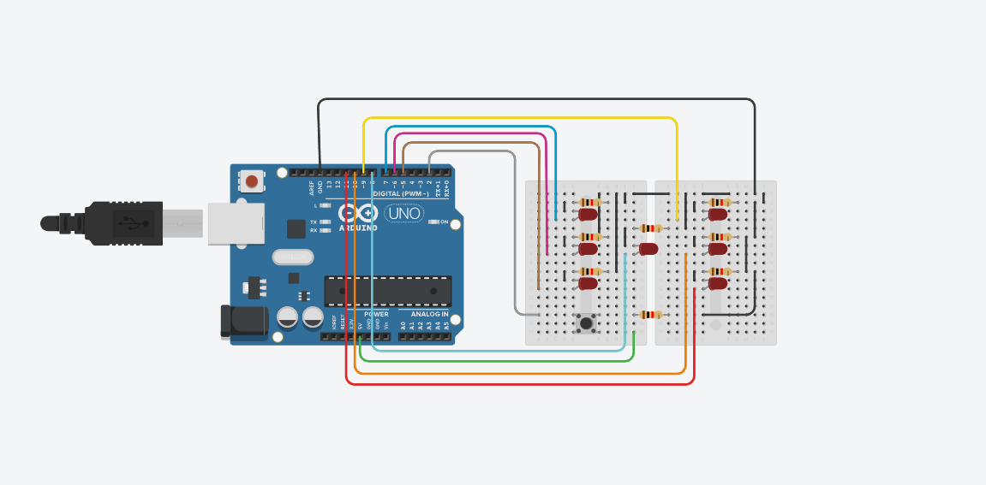

CÓDIGO
void setup()
{
randomSeed(analogRead(0));
pinMode(2, INPUT_PULLUP);
pinMode(4, OUTPUT);
pinMode(5, OUTPUT);
pinMode(6, OUTPUT);
pinMode(7, OUTPUT);
pinMode(8, OUTPUT);
pinMode(9, OUTPUT);
pinMode(10, OUTPUT);
}

void apagaTudo()
{
digitalWrite(4, LOW);
digitalWrite(5, LOW);
digitalWrite(6, LOW);
digitalWrite(7, LOW);
digitalWrite(8, LOW);
digitalWrite(9, LOW);
digitalWrite(10, LOW);
}

void sorteia()
{
int valor = random(1, 7);

apagaTudo();

if (valor == 1) {
digitalWrite(8, HIGH);
}
if (valor == 2) {
digitalWrite(7, HIGH);
digitalWrite(11, HIGH);
}

if (valor == 3) {
digitalWrite(7, HIGH);
digitalWrite(11, HIGH);
digitalWrite(8, HIGH);
}
if (valor == 4) {
digitalWrite(5, HIGH);
digitalWrite(11, HIGH);
digitalWrite(7, HIGH);
digitalWrite(9, HIGH);
}
if (valor == 5) {
digitalWrite(11, HIGH);
digitalWrite(5, HIGH);
digitalWrite(8, HIGH);
digitalWrite(7, HIGH);
digitalWrite(9, HIGH);
}
if (valor == 6) {
digitalWrite(5, HIGH);
digitalWrite(6, HIGH);
digitalWrite(7, HIGH);
digitalWrite(10, HIGH);
digitalWrite(9, HIGH);
digitalWrite(11, HIGH);
}

delay(4000);
apagaTudo();
}

void loop()
{
if (digitalRead(2) == HIGH) {
sorteia();
}
}

